**Introduction:**

**\*\*\*\*\*\*\*\*\*\*\*\*\*\*\*\*\*\*\*\*\*\*  
Our lives are becoming more and more entwined with digital activities and organizations like Swiggy and other software programs work to make our everyday tasks easier, there are still UI/UX issues and problem statements that need to be resolved.**

**1)Online Ticket Booking:**

**\*\*\*\*\*\*\*\*\*\*\*\*\*\*\*\*\*\*\*\*\*\*\*\*\*\*\*\*\*\*\*\*\*\*\*\***

**-The biggest obstacle is poor connectivity in the net. In this case, we should stop trying at all. Because even if we book**

**the desired ticket, the payment part can frustrate the whole activity.**

**- Sometimes our money will get stuck**

**-Poor network losses time and energy**



**2)App Navigation Complexity:**

**\*\*\*\*\*\*\*\*\*\*\*\*\*\*\*\*\*\*\*\*\*\*\*\*\*\*\*\*\*\*\*\*\*\*\*\***

**-Many applications, including those like Zomato, face navigation complexity issues. Users often get lost in a maze of menus, submenus, and options. This complexity can lead to frustration and reduce business. Simplifying navigation and providing clear paths will enhance user experience.**

**-Poor search results, a lack of filters, or slow response times gives bad user experience**

**-Complex design features reduces business and wastes time and energy**



**3)Mobile Banking:**

**\*\*\*\*\*\*\*\*\*\*\*\*\*\*\*\*\*\*\*\*\*\*\*\*\*\*\*\*\*\*\*\*\*\*\*\***

**-If we forget password it is very difficult to login**

**-No Actual Branches**

**-We do have Deposit Restrictions.**

**-Faster is Not Always More Convenient.**

**-Sometimes it is possible to overspend.**

**-Limited Services Scope. ...**

**-Sometimes if we exit from a particular page the entire App is exited.**

**4)Whatsapp:**

**\*\*\*\*\*\*\*\*\*\*\*\*\*\*\*\*\*\*\*\*\*\*\*\*\*\*\*\*\*\*\*\*\*\*\*\***

**- It has been best and worst experience**

**When it comes to WORK Experience( IF WE DELETE A MESSAGE AFTER SENT message is deleted but it is modified to opposite person who we send texts**



**5)EB bill payment APP:**

**\*\*\*\*\*\*\*\*\*\*\*\*\*\*\*\*\*\*\*\*\*\*\*\*\*\*\*\*\*\*\*\*\*\*\*\***

**- It is a long procedure. 1st we should create an account, login, enter password, number etc....**

**-Poor network leads to money struck**



**6) Barber shop/ Salon/ Beauty Parlour**

* **Many times user waiting timing time is major issue. It gets frustrated and reduces both energy business**
* **In this case , we can create an Application for booking availability date and time of user,**
* 

**7)Government website(I.E ANNA UNIVERSITY RESULT PUBLISHMENT)**

**\*\*\*\*\*\*\*\*\*\*\*\*\*\*\*\*\*\*\*\*\*\*\*\*\*\*\*\*\*\*\*\*\*\*\*\*\*\*\*\*\*\*\*\*\*\*\*\*\*\*\*\*\*\*\*\*\*\*\*\*\*\*\*\***

**-Many times server becomes down can't see results on time and it is delayed**

**-many time portal is not working**

**-Some times server crash**

**-time and energy waste**

* 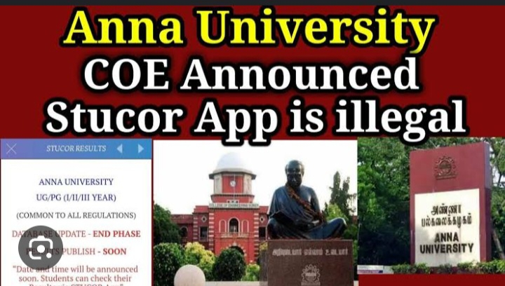

**8)Online Forms with Poor Error Handling:**

**\*\*\*\*\*\*\*\*\*\*\*\*\*\*\*\*\*\*\*\*\*\*\*\*\*\*\*\*\*\*\*\*\*\*\*\***

**- Forms that don't provide clear error messages are frustrating for users when they are trying to submit information**

**-Some times captcha is not working**

**-Late responses of any request**

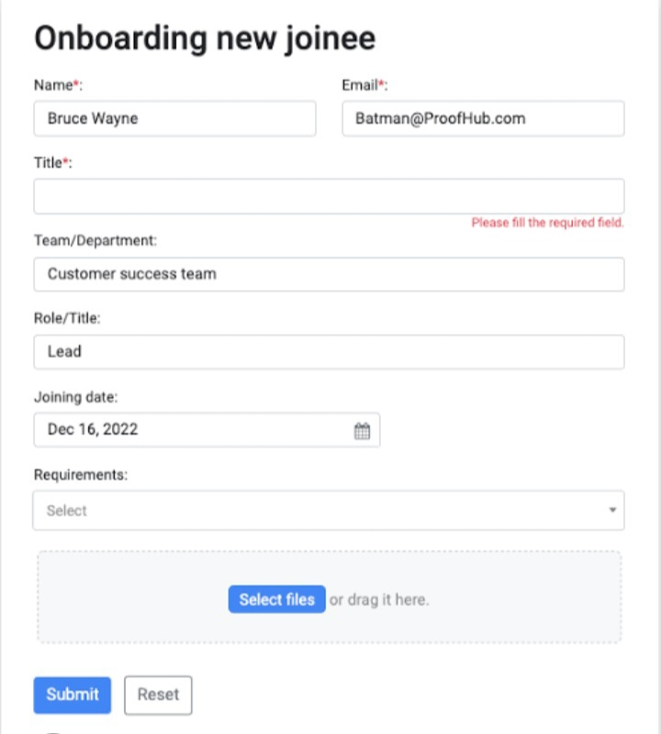

**9)Insufficient / Unsatisfied Customer Support:**

**\*\*\*\*\*\*\*\*\*\*\*\*\*\*\*\*\*\*\*\*\*\*\*\*\*\*\*\*\*\*\*\*\*\*\*\***

**-A bad customer service experience can cause serious damage to companies reputation and loss of business and customers**

**-Many times customer care agents won’t provide better solutions for user queries and solve problems**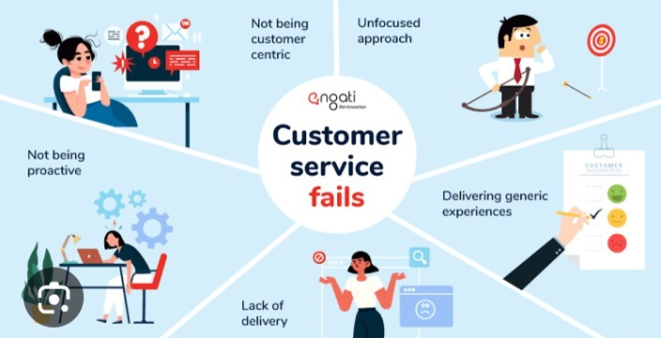

**10) Overwhelming Notifications:**

**\*\*\*\*\*\*\*\*\*\*\*\*\*\*\*\*\*\*\*\*\*\*\*\*\*\*\*\*\*\*\*\*\*\*\*\***

**While notifications can be useful, an excessive number of alerts can annoy users and lead the system to hang.**

**2types:**

**i)In App Notifications**

**ii) Push Notification**

**In App Notifications:**

**\*\*\*\*\*\*\*\*\*\*\*\*\*\*\*\*\*\*\*\*\*\*\*\*\*\*\*\*\*\*\*\*\*\*\*\***

* **In this case user gets notified inside application, when user is engaged with other activities they have won’t have time to login to App and check notifications**

**-it increases work and times**

**Push Notifications:**

**\*\*\*\*\*\*\*\*\*\*\*\*\*\*\*\*\*\*\*\*\*\*\*\*\*\*\*\*\*\*\*\*\*\*\*\***

**-A push notification is a short message that appears as a pop-up on a desktop browser, mobile home screen, or in your device notification center from a mobile app.**

**-Push notifications are typically opt-in alerts that display text and rich media, like images or buttons, which enable a user to take a specific action**

**-It gives better experiences.**

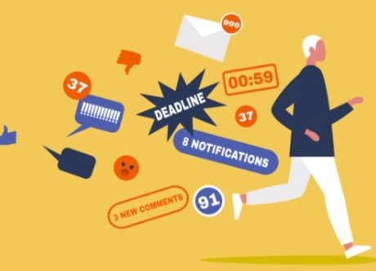

**.**

**Conclusion:**

**Resolving these 10 issues would greatly enhance the general user experience of digital goods and services. Digital experiences may be made more intuitive, effective, and pleasurable by UI/UX designers by understanding consumers’ needs and pain areas. Prioritizing user-centric design is essential as technology develops further in order to guarantee long-term profitability and user happiness.**